Name: Areeb Ansari Roll No:A3-B1-01

Practical 6
Aim: Construction of OBST

Problem Statement: Smart Library Search Optimization
Task 1:
Scenario:
A university digital library system stores frequently accessed books using a binary search
mechanism. The library admin wants to minimize the average search time for book lookups by
arranging the book IDs optimally in a binary search tree.
Each book ID has a probability of being searched successfully and an associated probability for
unsuccessful searches (when a book ID does not exist between two keys).
Your task is to determine the minimum expected cost of searching using an Optimal Binary
Search Tree (OBST).
Code:
#include <stdio.h>
#include <float.h>

void OptimalBST(double p[], double q[], int n,
double E[n + 1][n + 1],
double W[n + 1][n + 1],
int R[n + 1][n + 1]) {
int i, j, k, d;
double cost;

// Step 1: Initialization
for (i = 0; i <= n; i++) {
for (j = 0; j <= n; j++) { // Initialize to zero
E[i][j] = 0.0;
W[i][j] = 0.0;
R[i][j] = 0;
}
}

for (i = 0; i <= n; i++) {
E[i][i] = q[i];
W[i][i] = q[i];
R[i][i] = 0; // No root for empty tree
}

// Step 2: Compute for all intervals of increasing length
for (d = 1; d <= n; d++) {
for (i = 0; i <= n - d; i++) {
j = i + d;
E[i][j] = DBL_MAX;
W[i][j] = W[i][j - 1] + p[j] + q[j];

// Step 3: Try each key as root
for (k = i + 1; k <= j; k++) {
cost = E[i][k - 1] + E[k][j] + W[i][j];
if (cost < E[i][j]) {
E[i][j] = cost;
R[i][j] = k;
}
}
}
}
}

int main() {
int n, i, j;

printf("Enter the number of book IDs: ");
scanf("%d", &n);

int keys[n + 1];
double p[n + 1], q[n + 1];
double E[n + 1][n + 1], W[n + 1][n + 1];
int R[n + 1][n + 1];

printf("Enter %d sorted book IDs:\n", n);
for (i = 1; i <= n; i++) {
printf("Key %d: ", i);
scanf("%d", &keys[i]);
}

printf("\nEnter %d probabilities of successful searches (p[i]):\n", n);
for (i = 1; i <= n; i++) {
printf("p[%d]: ", i);
scanf("%lf", &p[i]);
}

printf("\nEnter %d probabilities of unsuccessful searches (q[i]):\n", n + 1);
for (i = 0; i <= n; i++) {
printf("q[%d]: ", i);
scanf("%lf", &q[i]);
}

OptimalBST(p, q, n, E, W, R);

printf("\nMinimum Expected Cost: %.4lf\n", E[0][n]);

printf("\nRoot Matrix (R):\n");
for (i = 0; i <= n; i++) {
for (j = 0; j <= n; j++)
printf("%3d ", R[i][j]);
printf("\n");
}

return 0;
}

Output:
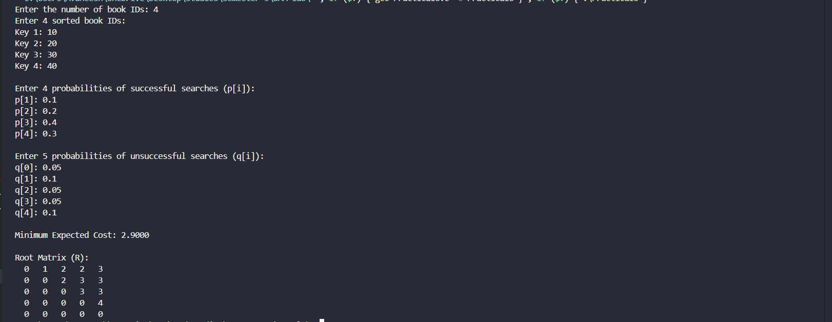
Task2:
